PROPOSAL:
To Paulding County Commissioners for

Fiber-to-the-Home (FTTH) Network Construction and Operation
In Jackson Township

Contact information:
Paulding County Commissioners
451 McDonald Pike Suite E
Paulding, Ohio 45879

1.1 Network Background
The Paulding County Commissioners and the Jackson Township Trustees are requesting proposals from Providers of High-Speed Fiber Networks (Network Providers) to build, manage and operate a Fiber to The Home (FTTH) Network that will provide gigabit Internet access service (1000Mbps) as well as cable TV service to businesses, homes, and community institutions within the Service Area. Jackson Township and Paulding County will provide support by assisting with and streamlining right-of-way and easement access.
The Network Provider will bear all the costs for the Network, including but not limited to design, engineering, construction, equipment, and insurance for the Network, up to the end user drop point or network interface device. In addition, the Network Provider will bear all the operating and maintenance costs of the Network.

1.2 Nature of Entities
This request for proposals is issued by the Paulding County Commissioners and the Jackson Township Trustees. Jackson Township is located in Paulding County and Paulding County is located within the State of Ohio.

1.3 Overview
This request is for the deployment and operation by a Network Provider of a high-speed fiber network for the citizens and businesses in the Service Area. The objectives are to establish a Network that:
- is able to offer retail broadband connection of 1 Gbps and at least 700Mbps throughput download speed over each connection provided to a premises;
- is able to support high quality data and video (cable TV) services;
- uses fiber-to-the-premises network architecture;
- covers 100 per cent of homes and small businesses in the Service Area;
- is rolled out and made operational progressively, on a demand driven basis, over 2 years from the date of execution of a contract between Paulding County Commissioners and Network Provider;

1.4 Rights of Way
Jackson Township Trustees (Jackson) and Paulding County Commissioners (Paulding) will allow the Network Provider to have access to necessary rights-of-way on property owned or controlled by Jackson and Paulding and property on which Jackson and Paulding have an easement. Jackson and Paulding will also cooperate with the Network Provider in efforts to allow the Network Provider to gain access to rights-of-way owned or controlled by third parties within the Service Area.

1.5 Relationship between Network Provider and Jackson Township and Paulding County
The Network Provider will be an independent contractor that provides all design, construction and operation services for the Network. Jackson and Paulding will not have any ownership stake in the FTTH facilities nor the entity that owns and operates the Network.

2. Services Sought
2.1 Description of Proposed Services
The Network Provider will design, build, install, own, operate and manage a complete high-speed communications Network within the Service Area. The system shall be Fiber-to-the-home Active E or GPON technologies and allow users access to and from the Internet and access to other services as required.

2.2 Service Area
See attached map.

3. Administrative Issues
3.1 Cost
Project Proposal ____________________
Project Homes Passed ____________________
Build Estimate _____$______________
Paulding County Contribution _____$ 168,020____
Total Project Estimated Network Provider Contribution _____$______________

American Rescue Plan Act of 2021 and 2022 funds are requested for this project from Jackson Township in the amount of $84,010 and Paulding County in the amount of $84,010 for a total contribution of $168,020.

3.2 Proposal Due Date
Proposals are due August 31, 2022

3.3 Use of Subcontractors
Network Provider may use subcontractors to fulfill any obligations in connection with the project. Use of subcontractors shall be subject to all applicable state and federal laws. Network Provider shall remain liable for fulfilling all its obligations on the project, and for any claims or damages arising from the subcontractor’s work.

3.4 Signatures

Network Provider Paulding County Commissioners
Date: Date:
Signature: Signature:
Name: Name: Roy Klopfenstein
Title: Date:
Signature:
Name: Mark Holtsberry
Date:
Signature:
Name: Mike Wieble

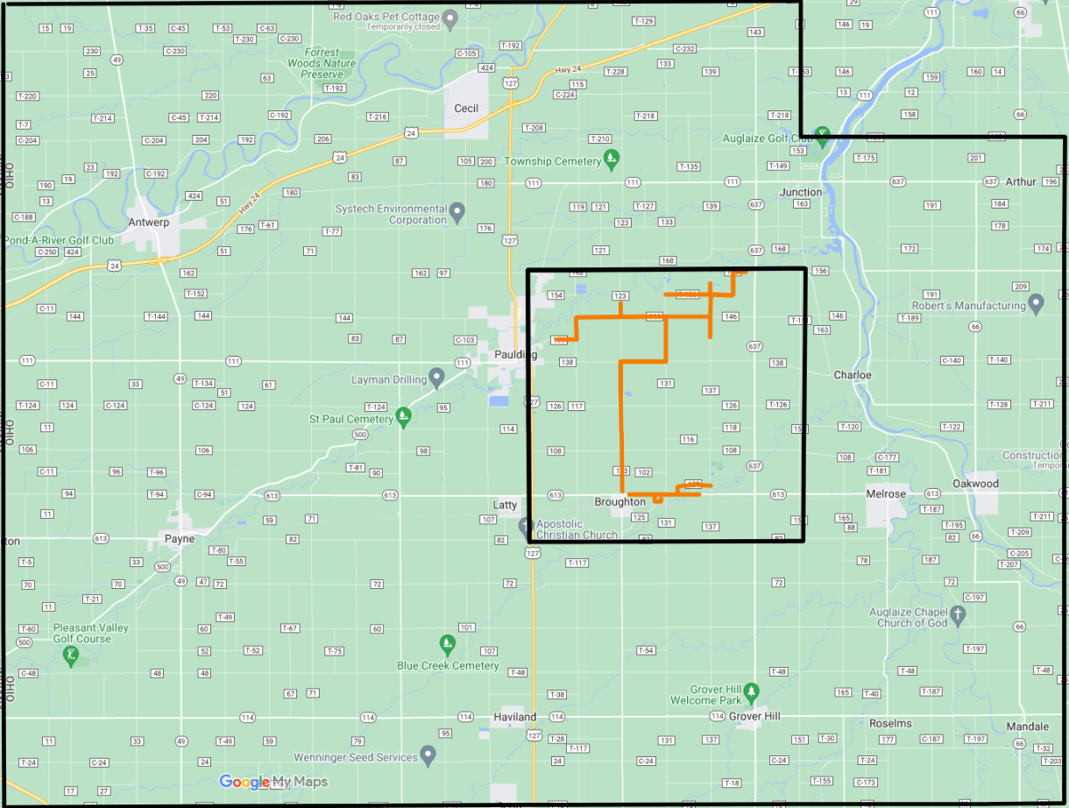
Paulding
County

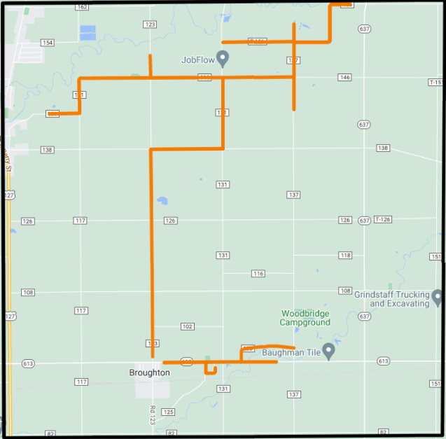
Jackson
Township

