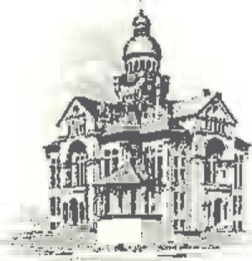
PAULDING COUNTY

COMMISSIONERS
451 McDonald Pike- Suite E ∙ Paulding, Ohio 45879

MONDAY
April 15, 2024
8:30 a.m. | Tim Yenser
9:00 a.m. | Ali Redmond & Don Foltz
9:30 a.m. | Tim Copsey & Kristen Schilt
10:30 a.m. | BOR Meeting
11:00 a.m. | OSU Quarterly Meeting

