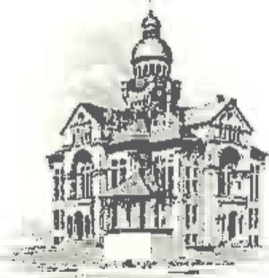
PAULDING COUNTY

COMMISSIONERS
451 McDonald Pike- Suite E ∙ Paulding, Ohio 45879

WEDNESDAY
April 17, 2024
8:00 a.m. | Joe Burkard (Executive Session if needed)
8:30 a.m. | Judge Beckman
9:30 a.m. | Lou Ann Wannemacher
10:00 a.m. | Shannon Ruschel
10:30 a.m. | Tim Yenser

