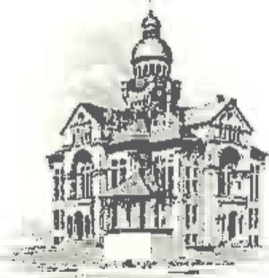
PAULDING COUNTY

COMMISSIONERS
451 McDonald Pike- Suite E ∙ Paulding, Ohio 45879

WEDNESDAY
April 24, 2024
8:00 a.m. | Joe Burkard (Executive Session if needed)
8:30 a.m. | Claudia Fickel
9:00 a.m. | Judge Rister
10:00 a.m. | Ed Bohn
11:00 a.m. | Audit Committee Meeting
11:45 a.m. | John Daeger & Jon Lichty

