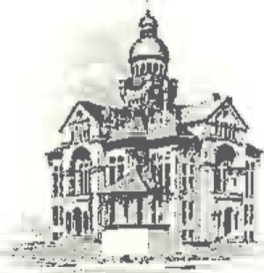
PAULDING COUNTY

COMMISSIONERS
451 McDonald Pike- Suite E ∙ Paulding, Ohio 45879

MONDAY
April 29, 2024
8:30 a.m. | Tim Yenser
9:00 a.m. | Jim Stripe, Cody Bowersock & Emmi Johnson
10:00 a.m. | Claudia Fickel & Stacy Clemens

