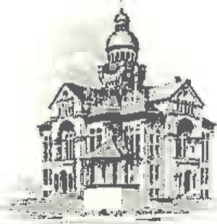
PAULDING COUNTY

COMMISSIONERS
451 McDonald Pike- Suite E ∙ Paulding, Ohio 45879

WEDNESDAY
May 8, 2024
8:00 a.m. | Joe Burkard (Executive Session if needed)
8:30 a.m. | Land Bank
9:30 a.m. | Sheriff Landers
10:30 a.m. | Travis McGarvey
11:00 a.m. | Jim Stripe, Cody Bowersock & Emmi Johnson
1:30 p.m. | Anna Gurney & Erica Noggle

