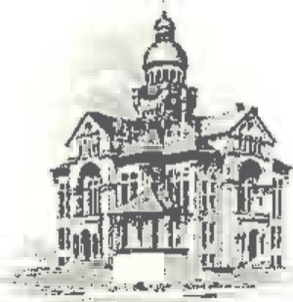PAULDING COUNTY

# COMMISSIONERS

451 McDonald Pike- Suite E ∙ Paulding, Ohio 45879

**WEDNESDAY**

**May 7, 2025**

|  |  |
| --- | --- |
| **8:00 a.m.** | **Joe Burkard (Executive Session if needed)** |
| **11:00 a.m.** | **Jay Klopfenstein** |