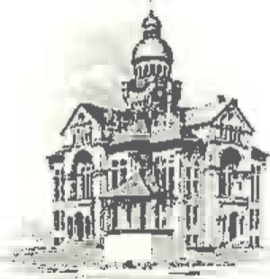PAULDING COUNTY

# COMMISSIONERS

451 McDonald Pike- Suite E ∙ Paulding, Ohio 45879

**WEDNESDAY**

**July 2, 2025**

|  |  |
| --- | --- |
| **8:00 a.m.** | **Joe Burkard (Executive Session if needed)** |
| **9:00 a.m.** | **Anna Gurney** |
| **10:00 a.m.** | **All Temp, Sheriff Landers, Chris Dilling & Tim Yenser** |
| **10:30 a.m.** | **Scott Strahley** |
| **11:30 a.m.** | **Jay Klopfenstein** |