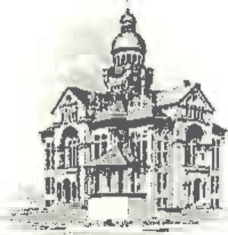PAULDING COUNTY

# COMMISSIONERS

451 McDonald Pike- Suite E ∙ Paulding, Ohio 45879

**MONDAY**

**July 28, 2025**

|  |  |
| --- | --- |
| **8:30 a.m.** | **Tim Yenser** |
| **11:00 a.m.** | **Ron Goedde** |

**WEDNESDAY**

**July 30, 2025**

|  |  |
| --- | --- |
| **8:00 a.m.** | **Joe Burkard (Executive Session if needed)** |
| **9:00 a.m.** | **Judge Rister** |
| **11:00 a.m.** | **Audit Committee Meeting** |