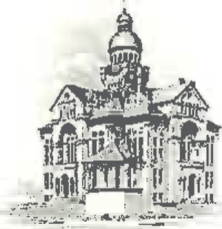
PAULDING COUNTY

COMMISSIONERS
451 McDonald Pike- Suite E ∙ Paulding, Ohio 45879

FRIDAY
April 3, 2026
CLOSING @ Noon
for
Good Friday

MONDAY
April 6, 2026
8:30 a.m. | Tim Yenser
9:00 a.m. | Judge Hyman
9:30 a.m. | Jay Klopfenstein
11:30 a.m. | Charlie Mlcek- Legislative Assistant Bob Latta’s office

